**CS3S Capstone**

**Stage 2 Documentation**

**BRRDEO001, SCTMAT003 & MNLGYA001**

**Use Case Narratives**

| **Use Case: Select Home Language** |
| --- |
| **Actor: User**  Stakeholders for this use case are Client (Maria Keet) and the Tutor (Yash Ramsamy). |
| **Description:**  When the game launches for the first-time, User will be prompted to select a language they wish to set the UI in. Available language options will be displayed on screen in the form of simple buttons, from which User will provide their selection via mouse-click.  If the User selects an available option, they will then be prompted to confirm the option via a text being displayed “Are you sure?” along with a “Yes” button and a “No” button. If User selects “Yes”, the application’s UI will be displayed in this language. If User selects “No” then the screen will return to the previous Language Options screen, where they can select another choice.  If there is no option appropriate for the User, the User can submit the language as a request where development can work on providing support for this language in the future. Among the language options there will be a “Not Displayed” button available to do this. Selecting this button will prompt User with a textbox where they can make their language submissions.  This use case is related to “Launch Game”, <<includes>> “Confirm Language Option” and <<extends>> “Make Language Submission”. |

| **Use Case: Select Word Category** |
| --- |
| **Actor: User**  Stakeholders for this use case are Client (Maria Keet) and the Tutor (Yash Ramsamy). |
| **Description:**  On the Main Menu screen there will be a “Play” button that upon being selected, prompts the user with an exercise category to select. We offer 6 categories: Animals, Transport, Colours, Numbers, Common Objects and Food. Team decided on these categories being a good foundation for learning a new language and expanding vocabulary with high usage words.  The categories will be displayed on screen as buttons, User will select one via mouse-click.  Once a category is selected, the User will be prompted with a “Ready?” being displayed on screen along with a “Yes” button and a “No” button so as to get confirmation and reduce User error.  If “Yes” is selected, this category will be an active learning path and User will be able to play games from this category (i.e., picture-word matching where the word fits the category).  If “No” is selected, the screen display returns to Category Select.  This use case is related to “Select Play”, <<includes>> “Confirm Category Option”. |

| **Use Case: Get Hint** |
| --- |
| **Actor: User**  Stakeholders for this use case are Client (Maria Keet) and the Tutor (Yash Ramsamy). |
| **Description:**  For any exercise/game in the app, there will be some form of player aid given so that learning is guided.  Users will be able to get a hint via a “Hint” button located in one of the corners on the screen.  In picture-word matching games, the hint is provided via reduction of incorrect pictures, for example if there are 4 available pictures to choose from, after the “Hint” button is selected, the User will have 2 pictures to choose from.  In text-input games, the hint is provided via a censored version of the correct answer being displayed.  The User will only be allowed a single hint, these are relatively simple games, and any additional player aid will remove any sort of challenge or gamification aspects to it as it will be notes rather than a game.  This use case is related to “Start Game” and <<includes>> “Close Hint” |

| **Use Case: View Progress** |
| --- |
| **Actor: User**  Stakeholders for this use case are Client (Maria Keet) and the Tutor (Yash Ramsamy). |
| **Description:**  On the Main Menu Screen there will be a “Progress” button.  If the User selects this button, a Progress tracker screen will be displayed.  The number of successfully completed exercises will feature at the top of the screen (“You’ve completed XX exercises!”) as well as a simple visual display of how far along the learning path they are. This could be in the form of a simple line showing how many exercises they’ve completed out of the total.  The User will be able to close the Progress tracker screen by use of a “Back” button which returns them to Main Menu, there is no alternative path here and User cannot view Progress during an exercise/game as Team has decided to try to limit distractions during the learning process.  The related use case is “Select Progress”. |

| **Use Case: Reset State** |
| --- |
| **Actor: User**  Stakeholders for this use case are Client (Maria Keet) and the Tutor (Yash Ramsamy). |
| **Description:**  To enhance User customizability, there is a “Reset” option available in Main Menu. As this app relies on the User managing their own time efficiently to learn, we must account for a User not being able to use the app for months at a time and wishing to restart their learning path.  The “Reset” options resets the progress tracker and User will no longer be able to continue from previous use, essentially when launching the game, it will be like the first time, and they will need to select a UI language again.  Upon selecting the “Reset” button, User will be prompted with a warning text “This will remove all progress. Do you wish to continue?” along with a “Yes” and a “No” button.  If User selects the “Yes” button, the reset is confirmed and progress will be set to 0, system will return to the Language Options screen.  If User selects the “No” button, they are returned to the Main Menu.  This use case <<includes>> “Confirm Reset” and <<extends>> “Select Home Language” |

**Class Diagram:**

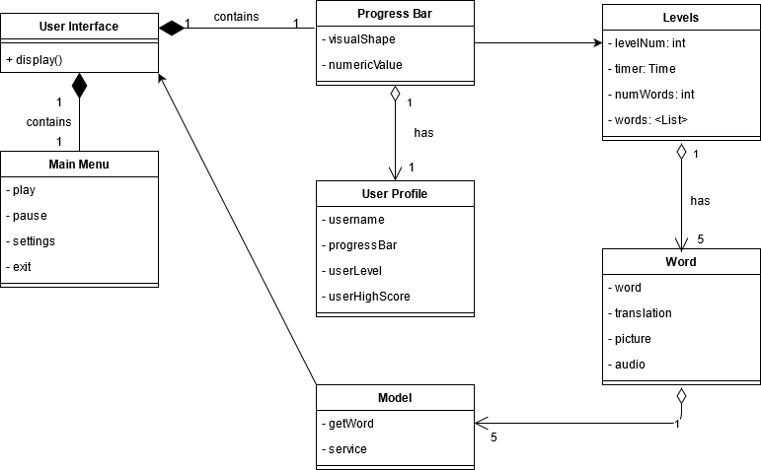

**State machine diagram:**

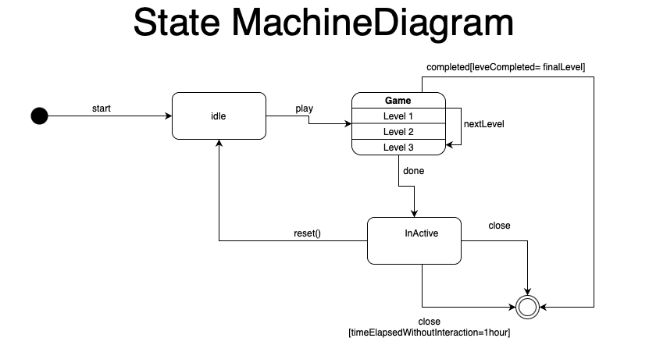

**Gantt Chart:**

*As we are using waterfall methodology all tasks are dependent upon completion of the previous task.

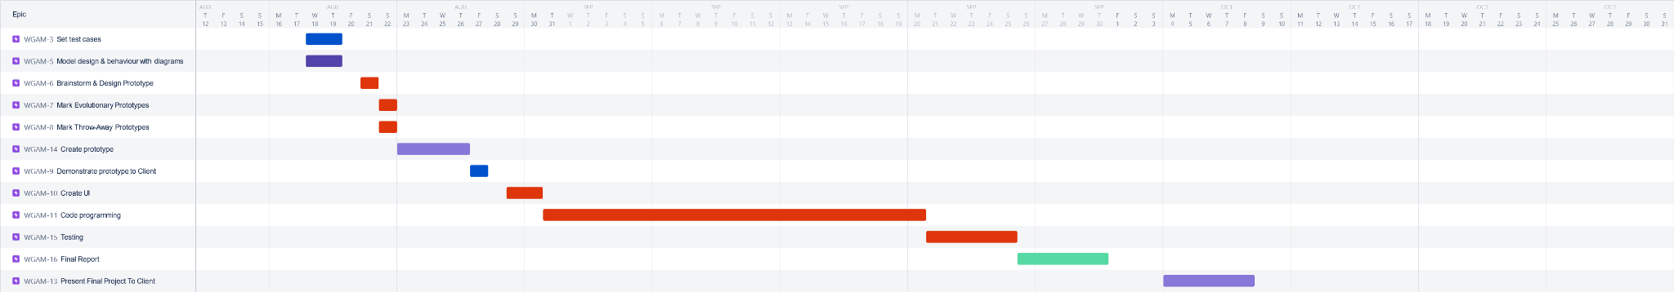

**Test Plan:**

| Test case number 1 | Inputs: One of our games will require that players input text for our text-based game in which players need to type the correct translation of the word displayed on screen. After that they would hit enter or click a confirm button that would then compare their input to the correct word and then tell them if it was correct or incorrect.  Tested Behaviour: In an ideal scenario the input would use only text and have the correct capitalizations. In this case the system should display a message informing the user if the input was right or wrong. However, the system also needs to accommodate the user using numbers or symbols. In such a scenario the result is unlikely to line up with the correct word and therefore should simply inform the user that their answer was wrong. The system’s comparators must be designed such that they do not break when encountering an unexpected input. Capital letters should be ignored in the comparison and the word should be considered correct even if the capital letters are not the same.  Outputs: A message displaying whether or not the user is correct or incorrect. An error message should not be necessary for an unexpected input. |
| --- | --- |
| Test case number 2 | Inputs: In our game you can match the pictures to the given words. You are shown the word and then click the picture that is associated with that word.  Tested Behaviour: There will need to be tests to see if the images click-box is accurate and things in place to prevent users from selecting more than one picture at once.  Outputs: Clicking the picture should result in a transition to a message informing the user if they are correct or not. Clicking anywhere else that isn’t a button with another function should do nothing. |
| Test case number 3 | Inputs: There will be a reset button that the user can use to reset their progress in the game should they wish to start over.  Tested Behaviour: The reset button should delete the user's save data after a follow up question asking for confirmation. The experience bar needs to be reset.  Outputs: A confirmation screen should be displayed upon clicking the reset button. If canceled, the game should return to the previous screen. If confirmed, the game should return to the home screen and the user's progress should be reset. |
| Test case number 4 | Inputs: Closing the game using the close button.  Tested Behaviour: Closing the game should not result in experience and level values being reset. They should be maintained the next time the user opens the game.  Outputs: All values remain the same after the game is reopened. |
| Test case number 5 | Inputs: When a game is complete the user should gain experience toward their next level up.  Tested Behaviour: Upon confirming the completion of a game, experience should be added to an experience attribute and the experience bar/number should change to reflect this.  Outputs: The user will see a change in the experience they have through a visual indicator. |